**Java Voting System**

Name:- Prashik Vishal Shinde

GitHub Username:- DevilPRash

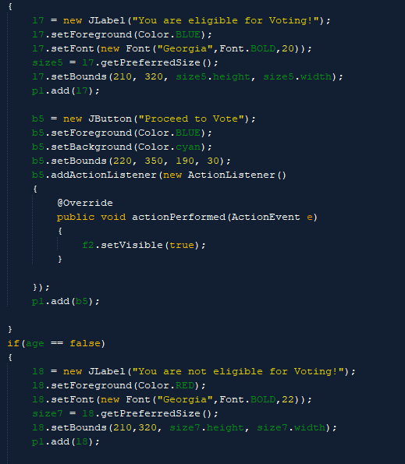

OutPut:→

And It will continue…